GALLOWAY
Friday 4th to Monday 7th May 2018
The AHSS 2018 Spring Study Tour will be to Galloway in south west Scotland, exploring the built heritage of Kirkcudbrightshire and Wigtownshire. We will be ‘on tour’, starting in Edinburgh with a pick-up in Glasgow and based near Gatehouse of Fleet, and then Stranraer. We will be accommodated in style, staying in the celebrated Cally Palace Hotel, begun in 1763 by Robert Mylne as the country house of the Murrays; it has substantial and important landscaped gardens. Then to its sister, the North West Castle Hotel, the 1820s former townhouse of Sir John Ross (he discovered the ‘North West Passage’) which is on the shores of Loch Ryan. Both hotels have excellent facilities including gyms and swimming pools.
The tour will be led by Simon Green and Adam Swan and administered by Caroline McFarlane.
Galloway is scenic, remote from the central belt, and with a heritage reflecting Anglian, Norse and Irish influences. From the 12th century Cistercian abbeys of Dundrennan and Glenluce there are castles, tower houses, parish churches, laird’s houses, Victorian mansions, farm steadings, mills, tollbooths, lighthouses and a whole variety of towns and villages steeped in history and character. As well as Gatehouse and the port of Stranraer to explore, there are the county towns of Wigtown, Scotland’s book town and the picturesque artists’ town of Kirkcudbright, as featured in Dorothy Sayers’ Five Red Herrings, and includes EA Hornel’s home and studio (previously the town house of the Murrays), and Jessie M King and EA Taylor’s house. Galloway was also the setting for much of John Buchan’s The Thirty Nine Steps. Elrig and Montreith have Gavin Maxwell associations. Villages such as Creetown, Whithorn, Newton Stewart, Minnigaff and Portpatrick also have much to offer. The Scots baronial mansion of Threave House, has remarkable teaching gardens, run by the National Trust for Scotland, and Castle Kennedy has an 18th century landscape restored by JC Loudon in 1841 and Logan Botanic Garden (RBGE), half way doen the Rhins of Galloway, has Scotland’s best collection of exotic plants; and not far off is Glenwhan Gardens and Arboretum.

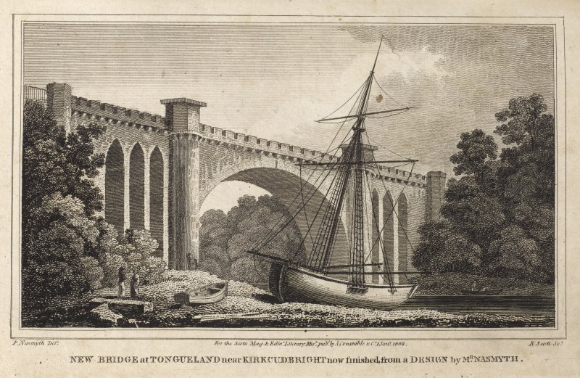

The Knockbrex estate near Borgue has an idiosyncratic range of Edwardian buildings provided by a Manchester textiles merchant. Old Place of Mochram has work by the later generation Arts & Crafts architects including Robert Weir Schultz and Ernest Gimson. In the 1930s the Galloway Hydro-Electric Scheme built a series of distinctive power stations, dams and associated structures, now sitting well in the landscape and looking very contemporary. (The above is to give a flavour of the area, and will not necessarily be included in the tour!).

The cost of the tour is £510 per person, based on two members sharing a room and will include visits, accommodation, transportation, meals and refreshments as provided. A limited number of single occupancy rooms will be available, subject to a supplement of £90.

To note your interest, please complete and return the form below, along with a deposit of £55 per person payable to ‘Architectural Heritage Society of Scotland’ in full, by 10 January 2018. If the tour is over-subscribed, places will be allocated and a waiting list will be created. If you are applying for a single place but prefer to share a room please indicate this (and if possible with whom*) on the form below. Please also let us know of any dietary requirements. The society operates a cancellation policy, which will be sent out with deposit acknowledgements.

………………………………………………………………………………………………………………………………………….

NATIONAL SPRING STUDY TOUR: KIRKCUDBRIGHT
Fri 4 May to Mon 7 May 2018

Please reserve………. place(s) for me/ us on the Spring Study Tour.

I/ we would like a: Single Room Twin Room Double Room

*I can share with:

First name (known-as) & surname:

Address:

Telephone:

Email:

Dietary Requirements:

Please return this form to the National Office, 15 Rutland Square, Edinburgh EH1 2BE

