AGM 2017 The Engine Shed Booking Form

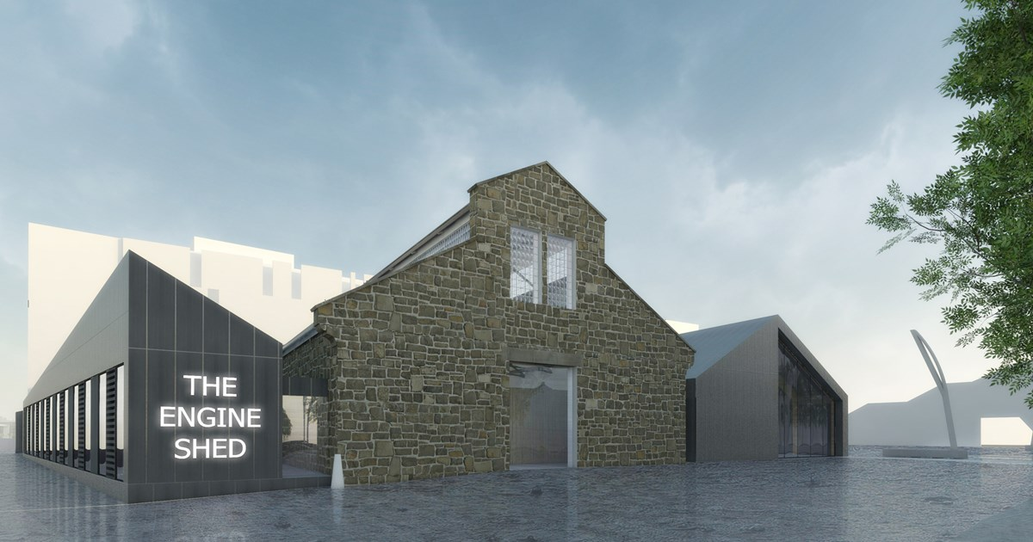

The AHSS are delighted to hold our 61st AGM at Scotland’s new Building Conservation Centre, the Engine Shed, Stirling, hosted by Historic Environment Scotland.

Welcome teas and coffees will be served at 11am, with the AGM beginning at 12pm. A sandwich lunch will follow at 1.30pm. A member of the HES team will talk us through the project to restore and extend the Engine Shed building, whilst also explaining the future aims of the conservation centre, from 2.30-3.30pm.

The Engine Shed will be open to members of the public from 10am to 4pm, giving you time to explore the centre and watch the 3D video experience either before or after the AHSS activities.

Attendance at the AGM is free and open to all.
………………………………………………………………………………………………………………………

Name:……………………………………………………………......Address:…………………………………..

………………………………………………………………………………………………………………………
Contact telephone:…………………………………….Email:…………………………………………………..

I wish to book ……… places for lunch at a cost of £12 per person. Total cost £……….

Please note any dietary requirements below:
………………………………………………………………………………………………………………………..

I enclose a cheque payable to “Architectural Heritage Society of Scotland” for £………….
Or- I shall pay by BACS to: 40-52-40 00018160

Please tear off and return, or email to the National Office at 15 Rutland Square, Edinburgh
EH1 2BE to book your lunch.

The AHSS National Accounts will be available in hard copy on the day and in advance on our website www.ahss.org.uk/Accounts2017

Directions to the Engine Shed

The Engine Shed, Forthside Way, Stirling, FK8 1QZ

The building is clearly visible from the bus and train station, and is easy walking distance from both. Cross the foot bridge over the railway lines and continue 150m east to the Engine Shed. The foot bridge has a lift at both ends for ease of access.

There is no parking at the Engine Shed itself, but there is a public car park 350m away which incurs a small charge (around £1.50 per day), Forthside Car Park is located at 2a Forthside Way, Stirling FK8 1QZ.

AHSS National Office | 15 Rutland Square, Edinburgh EH1 2BE
0131 557 0019 | nationaloffice@ahss.org.uk | www.ahss.org.uk

