Limited places still available!
AGM 2016 BOOKING FORM

Fyvie Castle, Turriff, AB53 8JS, Saturday 15th and Sunday 16th October 2016

To honour our 60th Jubilee, the AHSS North East Group will host a weekend of celebrations.

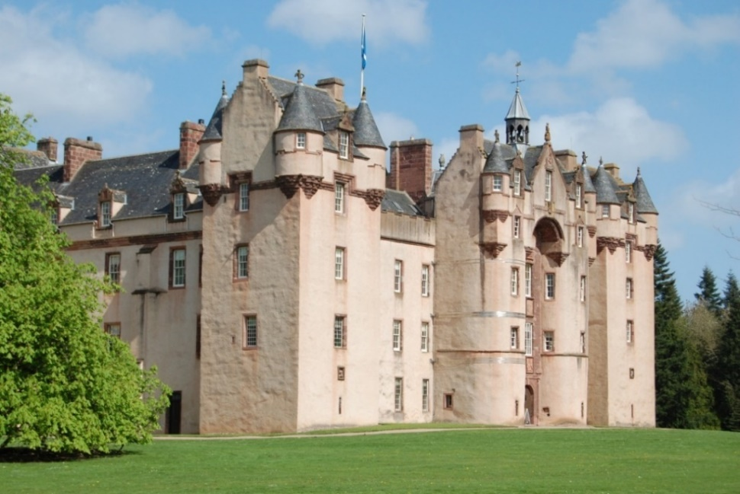
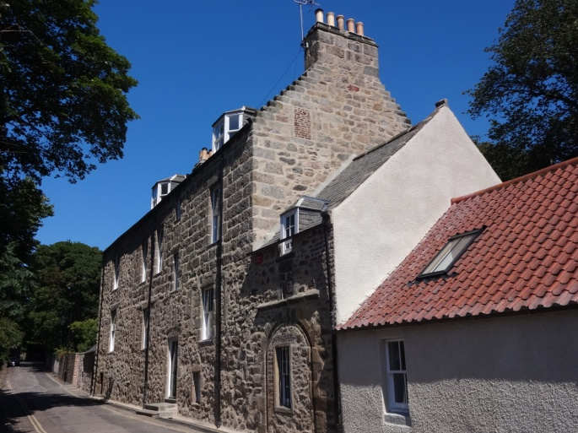

Saturday Programme:
Members will meet at the Carmelite Hotel at 11am to drop off luggage. We will be collected by coach and taken to the Lochter Activity Centre for a lunch of soup and sandwiches. From there we will travel to the spectacular Fyvie Castle for an afternoon and evening of special activities, including: a tour of the building, our 60th AGM, afternoon tea, drinks reception, Jubilee Dinner and a talk by award-winning Conservation Architect, Dave Chouman. We will return to the Carmelite Hotel on Saturday evening by coach.

Sunday Programme:
Following breakfast at the hotel, we will visit Chaplain’s Court in Old Aberdeen, where we will receive a tour of this privately owned, historic property. There will be a light lunch and talk on the history and heritage of Aberdeen. We will be sure to visit our iconic Aberdeen Old Town House for a photo opportunity before returning to the hotel to collect luggage.
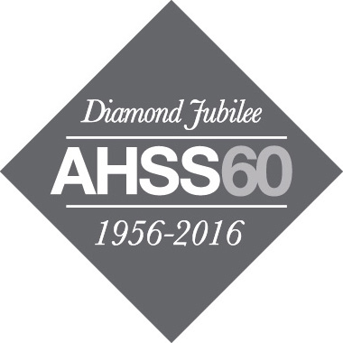
AHSS National Office | 15 Rutland Square, Edinburgh EH1 2BE
0131 557 0019 | nationaloffice@ahss.org.uk | www.ahss.org.uk
The Architectural Heritage Society of Scotland (AHSS) is a registered charity: SC007554REG. The Society is registered as a Company Limited by Guarantee: SC356726
President: Simon Green MA FSA FSA Scot.
…………………………………………………………………………………………………………………………………..
Name:……………………………………………………………......Address:…………………………………………………

…………………………………………………………………………………………………………………………………….
Contact telephone:………………………………………………….Email:…………………………………………………….

Saturday lunch at Lochter Activity Centre, 12.30pm, for ………. people @ £10 pp. Total:

AGM and tour at Fyvie Castle with afternoon tea for ………..people. No charge, all welcome.

Drinks reception, Jubilee Dinner and talk for ……….. people @ £45 pp. Total:

Sunday visit to Chaplain’s Court, lunch and talk for……..people @ £15 pp. Total:

I enclose a cheque payable to Architectural Heritage Society of Scotland for: ..........................................................
Further information:

Fyvie Project Stonework Conservation Project, Fyvie Castle, Turriff, Aberdeenshire

The National Trust for Scotland are in the process of developing proposals for a major scheme of repairs to their iconic Fyvie Castle. This is to include conservation repairs to the numerous carved stonework features around the Castle, including the decoratively carved stone finials, some of which are several centuries old.
David Chouman, Conservation Architect, is leading the team of consultants on this element of the project, and will present further information on the proposed works at the property.

Chaplain's Court, Old Aberdeen

With elements dating back to the early 16th century, over the past five years Chaplain's Court has undergone a programme of major repair & alterations for its private owners. These works have included conservation-led repairs to the property fabric, reinstatement of the original arched Pend into the main accommodation, construction of oak-framed structures to the private garden elevation, and redevelopment of the street-side garden to a bespoke design. The Project attained the Conservation Category Award at the 2015 Aberdeen Society of Architects Design Awards Scheme.
David Chouman, Conservation Architect, will present further information on these works at the property, by kind permission of Prof. Claude & Mrs Irene Wischik.

Accommodation:
Accommodation has been reserved at the historic Carmelite Hotel in the Merchant Quarter, Aberdeen. Please contact the hotel directly to make a booking and mention the ‘AHSS’ as we have secured the following rates.

Single room B&B: £55
Double room, single occupancy B&B: £60
Double room B&B: £75

Carmelite Hotel, Stirling Street, Merchant Quarter, Aberdeen, AB11 6JU.

01224 589 101 | info@carmelitehotels.com

Please make your own arrangements for travel to and from Aberdeen.

Please note that elements of the weekend may be subject to change and you will be notified in the event of this.

Student discount available, please get in touch with the AHSS National Office to find out more.

Please return your booking form the AHSS National Office, 15 Rutland Square.

